Chapter 4 Isaac Newton on the road
Short investigation 4.2: Newton’s Second Law of Motion
Name:
Aim
To observe the relationship between mass, acceleration and force
Materials
Ticker timer, ticker tape, G clamp, sticky tape, string, weights (0.5 kg, 1 kg, 1.5 kg, 2.0 kg, 2.5 kg, 3.0 kg), additional 1 kg weight, dynamics trolley, scales, spring scale
Method
- Set up your ticker timer and use the G clamp to attach it to one end of your bench. Thread a 1 m length of ticker tape through the timer.
- Place the 1 kg mass on the dynamics trolley and attach it firmly in place using sticky tape. Put the trolley and weight on the scales and note the total mass in kg.
- Use sticky tape to attach the beginning of the tape to the end of the laden dynamics trolley.
- Tie one end of a 1 m length of string to the 500 g weight and the other to the loop at the top of the spring scale.
- Zero the spring scale and hook it to the front of the dynamics trolley.
- Hold the weight so that it hangs just over the end of the bench. Shorten the string joining the weight and the spring scale so that there is no slack in the string.

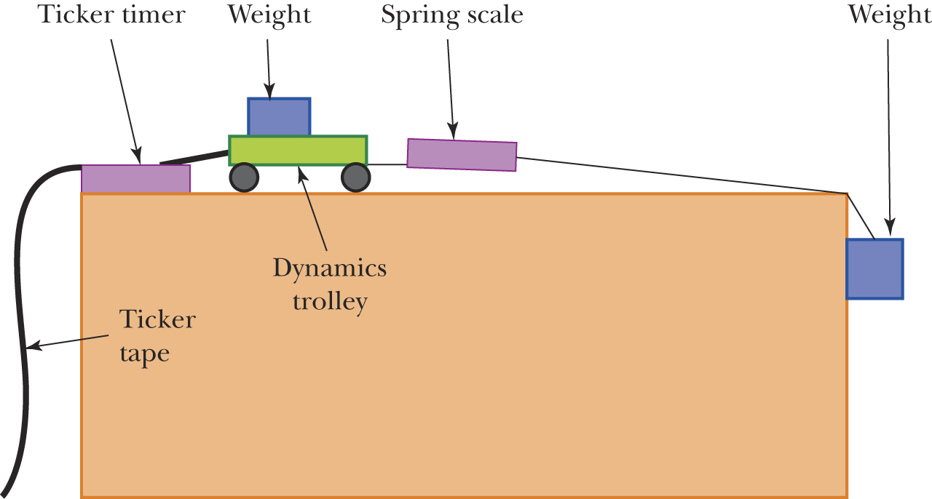
- Turn on the ticker timer and release the weight. This should, in turn, pull the dynamics trolley, which then pulls the tape through the ticker timer. Note the reading on the spring scale as the weight drops and enter it into table 4.2A.
- Use the ticker tape to determine the acceleration of the trolley. (If you don’t remember how to do this, refer to investigation 4.1.) Enter the value into table 4.2A.
- Repeat steps 3–8 for each of the other weights (1 kg up to 3 kg).
Results
Table 4.2A
Weight (kg) | Force (N) | Acceleration (m s^{–2})
0.5
1.0
1.5
2.0
2.5
3.0
Analysing the results
- On the graph section o, plot the results that you have entered in table 4.2A, ensuring that force (in N) is on the horizontal axis and acceleration (in m s^{–2}) is on the vertical axis. Draw a line of best fit through your results.


- What does the graph shape suggest about the relationship between the force applied to the trolley and the trolley’s resulting acceleration?
- In this investigation, the force of gravity acting on the falling weight was used to provide the force that pulled the trolley across the bench. As a result, we would ideally expect that the force measured by the spring scale (F) would be equal to the mass of the weight dropped (m) multiplied by 9.8 m s^{–2}.
  - Is this consistent with your results?
  - What reasons can you give for any discrepancies between these values?
Conclusion
State the relationship between the force applied to an object of fixed mass and its resulting acceleration.
Notes:

